Gillette Nature Association
Turkey Trail Run 2017 Sponsorship Opportunities

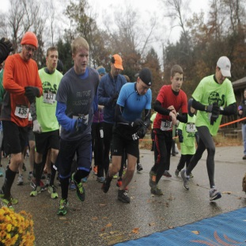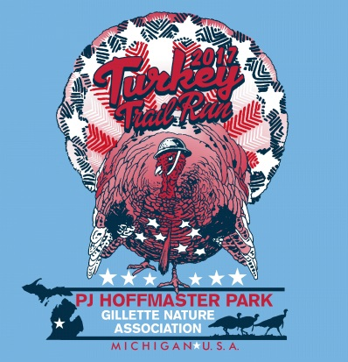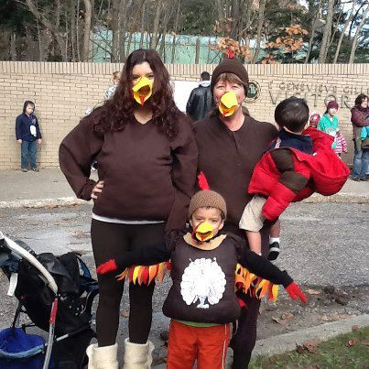

The Gillette Nature Association is a non-profit organization that promotes and sponsors interpretive activities and educational opportunities for the Muskegon and Ottawa county community surrounding the Gillette Visitor Center at P.J. Hoffmaster State Park. With the assistance of volunteers, the Association hosts over 200 yearly events to heighten public awareness and preservation of the unique natural features of the park, reaching nearly 35,000 people a year. In addition to hosting special events, the Association provides funding for new exhibits, interpretive trail markers, audio-visual programs, educational materials, and educational outreach programs.

The Turkey Trail Run event will be November 11, 2017. This year the race is on Veterans Day and we are offering half off for all veterans wanting to participate. Last year we had over 300 runners and have brought in over $15,000 for educational programming at the Visitor Center! We also reach over 100 children each year with a mile fun run, and many others through activities at the Visitor Center that day. Thank you for your consideration; we appreciate any support you can assist us with. Below are the levels of sponsorship:

All sponsors may put advertisements, goodies, coupons, etc., in the race bag given to all participants. Sponsors will be announced on our Facebook page, along with your logo and a link to your web page from gillettenature.org.

$250- Large logo on the middle of the T-shirt, 4 X 8 table and chairs to set up booth, and 2 free entries.

$500- Large logo on T-shirt at top, all $250 level options plus may place a large banner on finish line of their choosing.

$1000- Huge logo on the very top of the shirt. We will be providing a free banner to hang over the awards area or finish line. You will be announced as our main sponsor. 5 free entries. All other level options included. Open to ideas on any other promotions you might like. Any assistance you can give is greatly appreciated. Sponsorship contributions are also tax deductible. Please contact Donielle Routt with any questions you may have at 231-557-2955 or donielleroutt@yahoo.com.
- - - - - - - - - - - - - - - - - - - - - - - - - - - - - - - - - - - - - - - - - - - - - - - - - - - - - - - - - - - - - - - - - - - - - - - - - - - - - - - Please circle your contribution amount and mail to: 6585 Lake Harbor Dr. Muskegon, MI 49441

$250 $500 $1000
Business Name: ____________________________________________________

Website: __________________________________________________________

Address: __________________________________________________________

Contact: __________________________ Email: _________________________

Phone: __________________________________________________________

Please email your logo for marketing to Donielle Routt at donielleroutt@yahoo.com. We will send an invoice promptly for your accounts payable department. Again, thank you for supporting an amazing local organization!

